Swindon Youth Voice 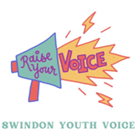
Thank you for completing this survey. Everyone completing the survey will be entered to win a £30 voucher as a thank you.

1. In the last 12 months have you taken part in any activities or projects in your community? If so, what were they? This could include activities like campaigning, fundraising or volunteering.

2. To what extent do you agree or disagree with the following statements?

 | Strongly agree | Agree | Unsure  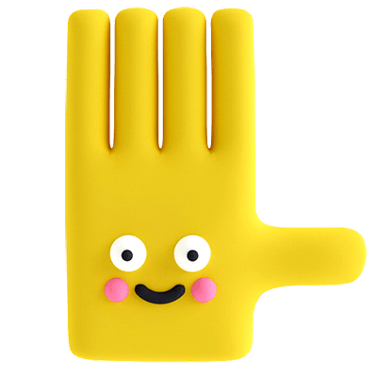 | Disagree  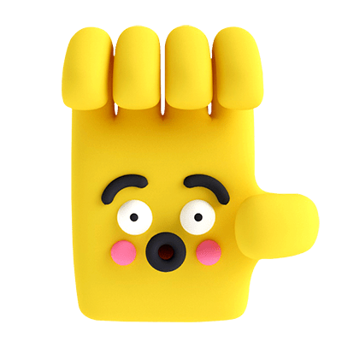 | Strongly disagree
I feel confident that I can make a change in my community
I feel my voice is valued
I feel part of a community
I know how to influence decisions that make a difference to me

If you would like to add any comments about any of your responses, please add them here:

3. Is there anything that would empower you to feel more involved in your community?

What is your date of birth?

What is your postcode?

Do you consider yourself to have a disability?
Please provide more information if you wish.

If you would like to stay in contact about Swindon Youth Voice what is your email address?

I understand that by completing this survey I am giving Swindon Youth Voice permission to store my personal data submitted through this form. This will be treated as confidential, and will not be disclosed to any third party without express consent.

Many thanks for completing

